**1. Implementing the Singleton Pattern**

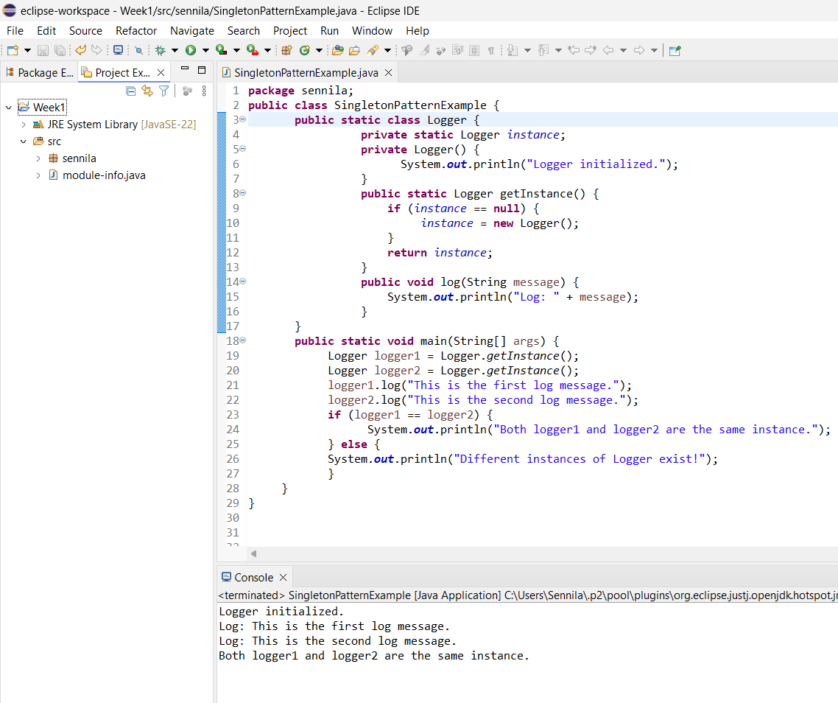

**2. Implementing the Factory Method Pattern**

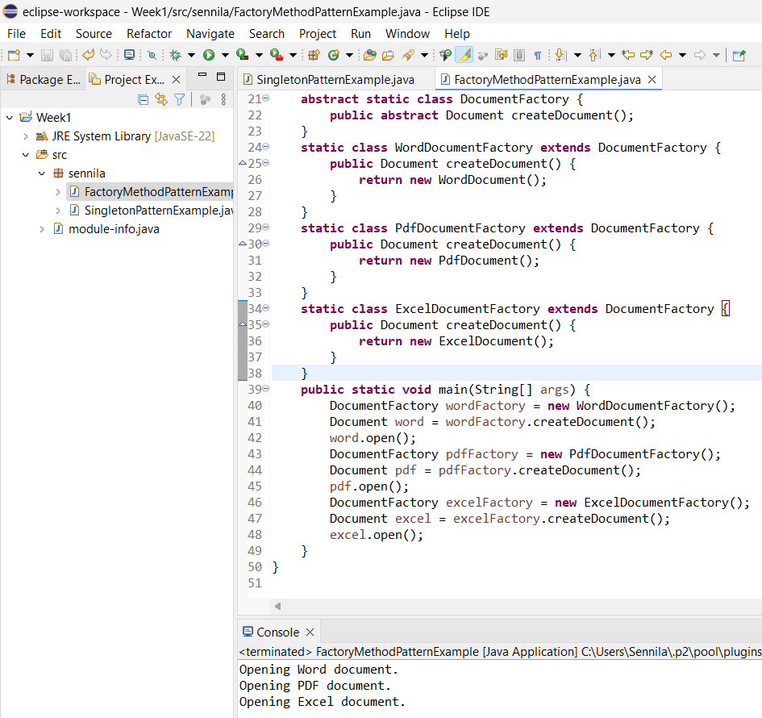

**3. Implementing the Builder Pattern**

**4. Implementing the Adapter Pattern**

**5. Implementing the Decorator Pattern**

**6. Implementing the Proxy Pattern**

**7. Implementing the Observer Pattern**

**8. Implementing the Strategy Pattern**

**9. Implementing the Command Pattern**

**10. Implementing the MVC Pattern**

**11. Implementing Dependency Injection**

